**The Key to Keeping Your Online Information Private**

**Diceware**What is a wobbly morally clicker mute jester oat? It’s a password phrase created by using the Diceware Word List. What is Diceware? It’s a system for creating strong passwords. Here’s how it works.

You will need the following:

Diceware word list. This is a list of 7,776 words. You can find it [here](http://world.std.com/~reinhold/dicewarewordlist.pdf).

Five dice (the kind you use in board games).

To begin, roll all five dice and write down the numbers you rolled. Next, take these five numbers and scroll through the word list until you find the word that corresponds with your number. This will be the first word in your password phrase. Now, repeat this process five more times until you have a total of six words for your password phrase.

If you don’t have access to dice, you can use these virtual [dice](https://www.random.org/dice/) from Random.org.

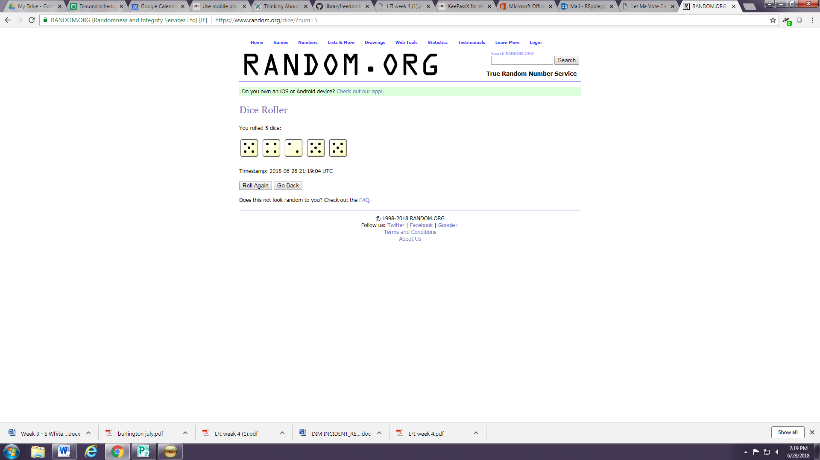

The password phrase you create will be nearly impossible to crack. Why? Because of randomness and unpredictability. Because there are so many words on the list, a five word password would take approximately 14 quintillion tries to guess (multiply 7.776 by itself five times to get this number).

 **KeePass X**

[KeePassX](https://securityinabox.org/en/guide/keepassx/windows/) is a password database. You can use KeePassX to generate random passwords for logging into websites or personal accounts, then lock them up with your Diceware pass phrase. To begin with KeePass X, click [here](https://securityinabox.org/en/guide/keepassx/windows/). Make sure to keep copies on your main computer and/or on a USB memory stick so you don’t lose your passwords.